Setting up AWS Cognito:
- Navigate to the AWS Management Console at https://console.aws.amazon.com.
- Log in with your AWS credentials.
- Ensure you're in the correct region (e.g., US East (N. Virginia) us-east-1) via the region selector in the top-right corner. Cognito user pools are region-specific.
- After logging in, use the search bar to find the Cognito service
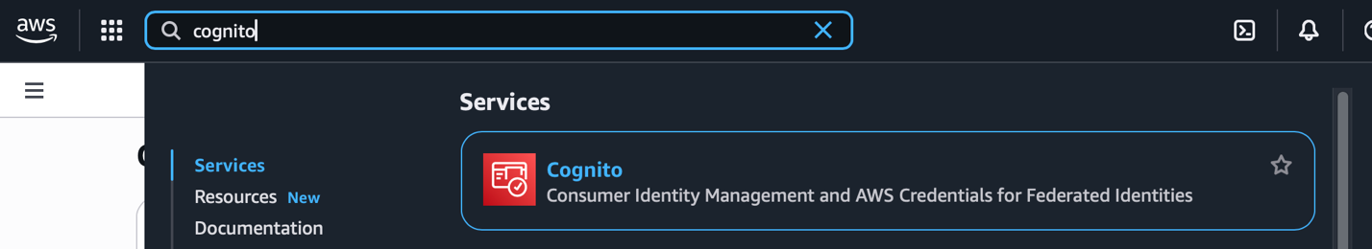
- Select Cognito and click on “create user pool” button.
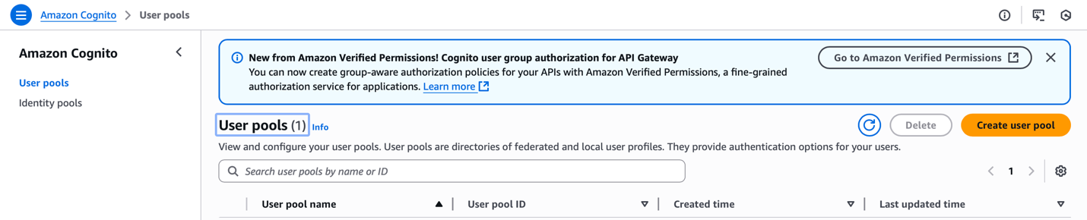
- Configure the settings as shown in the image below.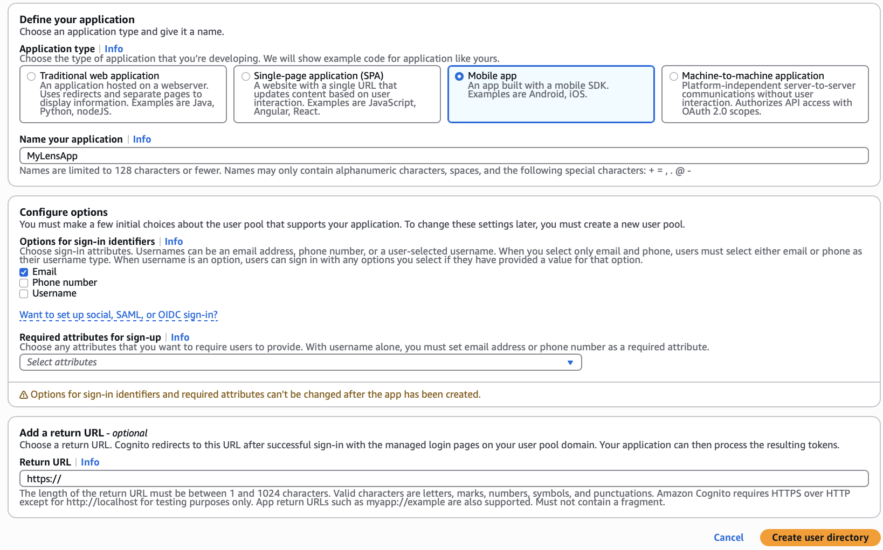
- Create User Directory and go to overview.
- User pool ID will be created.
- In left menu, under applications, click on App clients, click on the app we just created to view the app client id.
- Note down user pool id and app client id.

